CLOUD COMPUTING
LAB 11



Submitted To:
Engr. Shoaib

Submitted By:
Komal Kashif
BSE V-A
2023-BSE-031

Task 1 — Provider & Basic variable
task1_touch_main_tf.png
task1_main_tf_provider.png
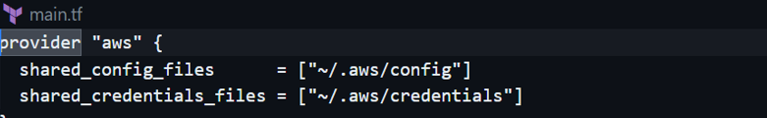
task1_terraform_init.png
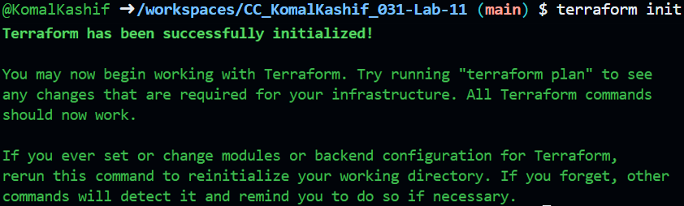
task1_variable_and_output_added.png
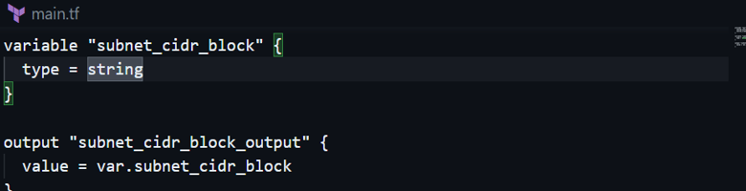
task1_apply_prompt_for_var.png
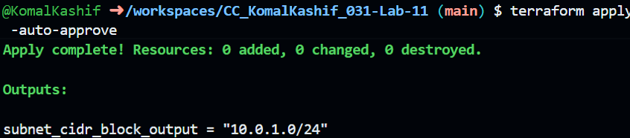
task1_apply_with_default.png
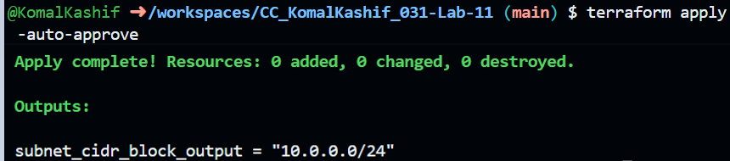

task1_env_var_set_and_apply.png
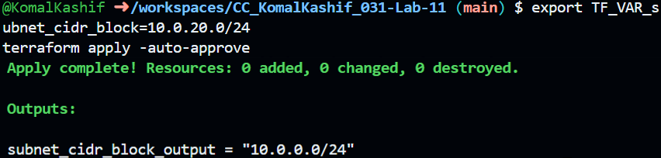
Task 2 — Variable validation & sensitive / ephemeral variables
task2_subnet_variable_with_validation.png
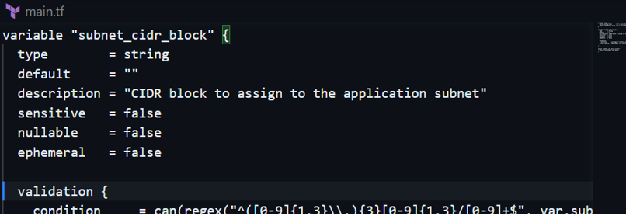
task2_subnet_validation_error.png
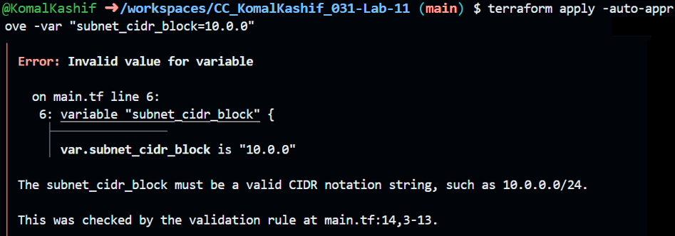
task2_api_token_variable_added.png
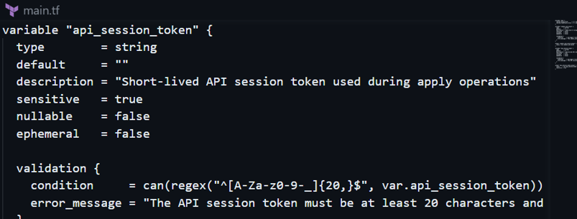

task2_api_token_apply_sensitive.png
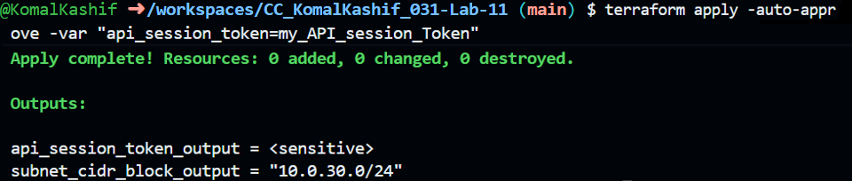

Task 3 — Project-level variables, locals, and outputs
task3_variables_added.png
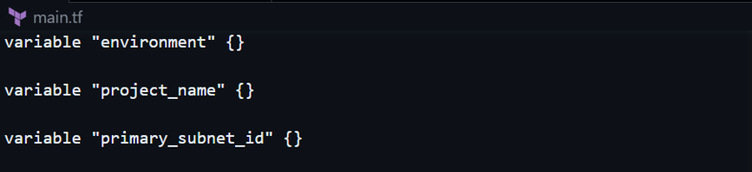
task3_terraform_tfvars_populated.png
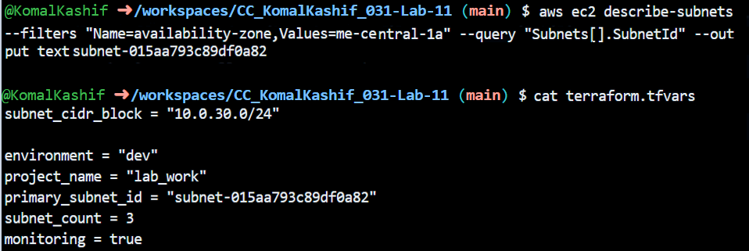
task3_locals_tf_created.png
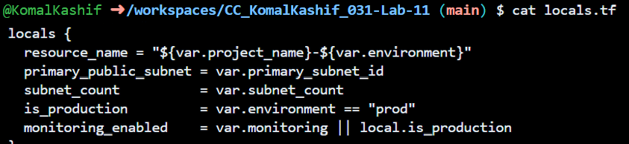
task3_outputs_apply.png
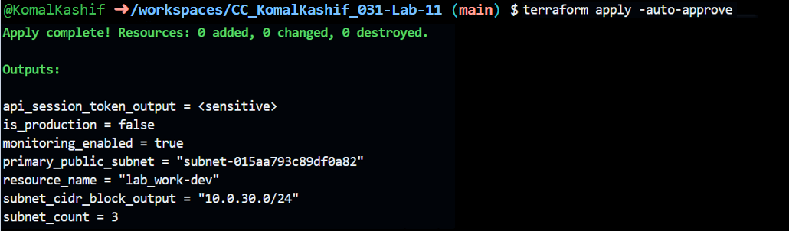

Task 4 — Maps and Objects
task4_tags_variable_added.png
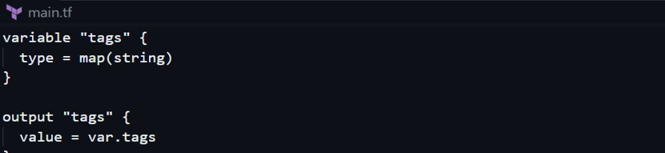
task4_tags_output.png
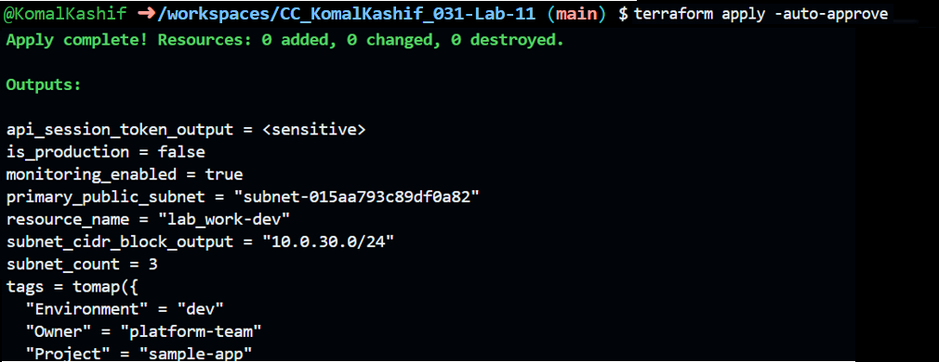
task4_server_config_output.png
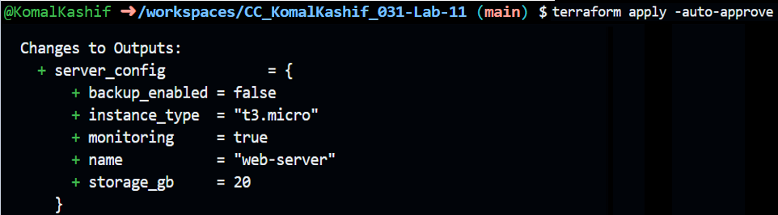

Task 5 — Collections: list, tuple, set & mutation via locals
task5_collections_defined.png
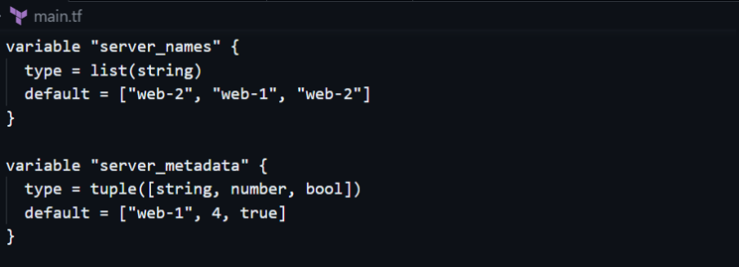

task5_compare_collections.png
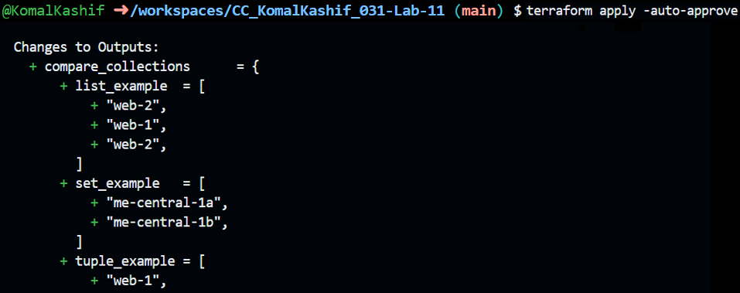
task5_locals_mutations.png
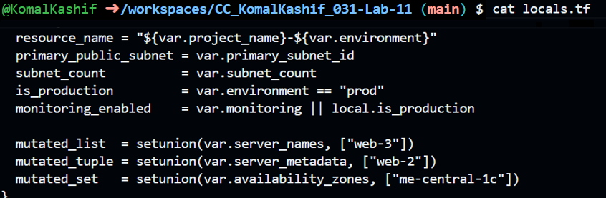
task5_mutation_comparison.png
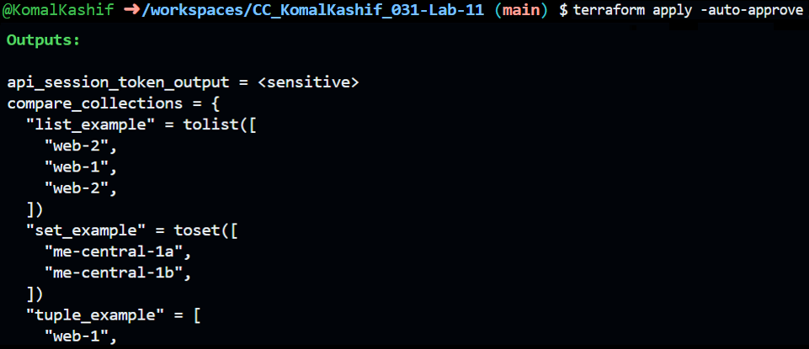
Task 6 — Null, any type & dynamic values
task6_optional_tag_variable.png
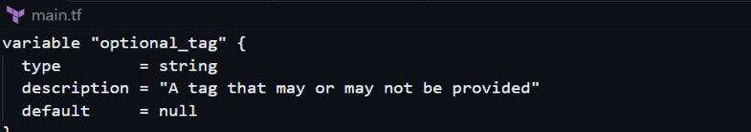

task6_locals_merge.png
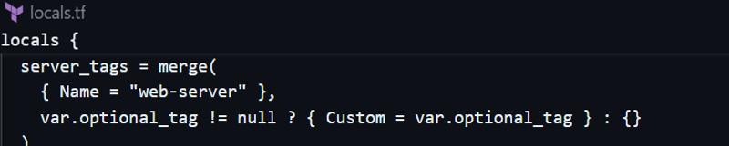
task6_optional_tag_no_value.png
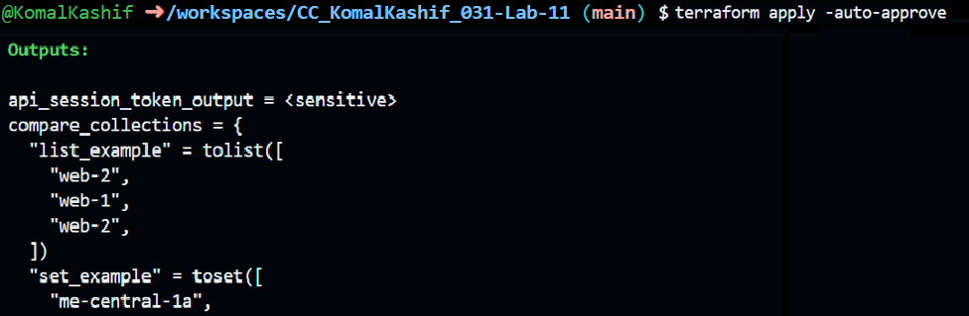
task6_optional_tag_with_value.png
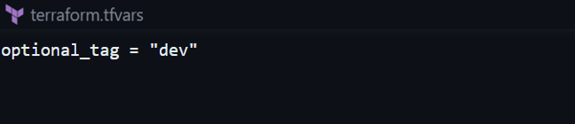
task6_dynamic_value_string.png
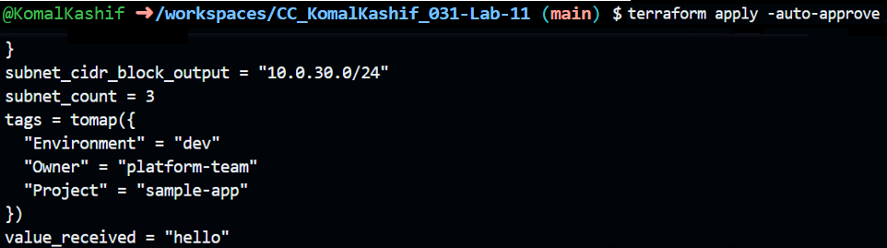
task6_dynamic_value_number.png
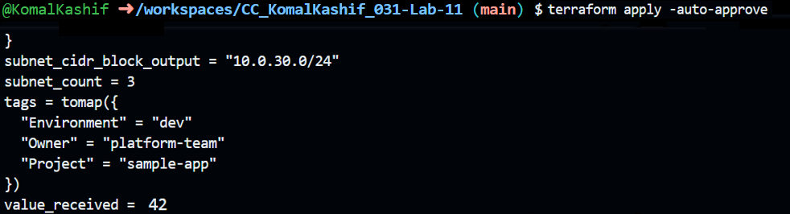

task6_dynamic_value_list.png
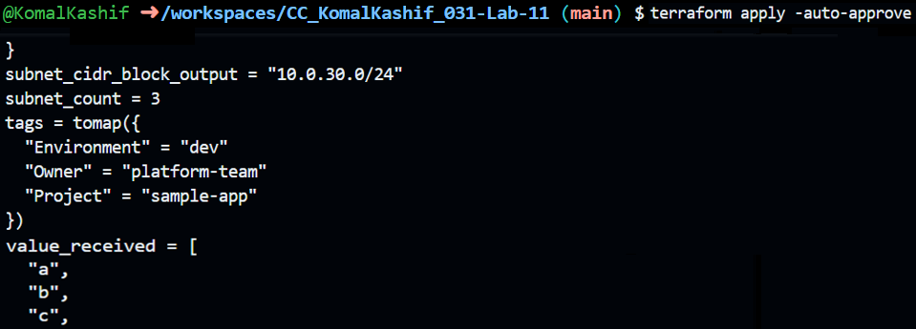
task6_dynamic_value_map.png
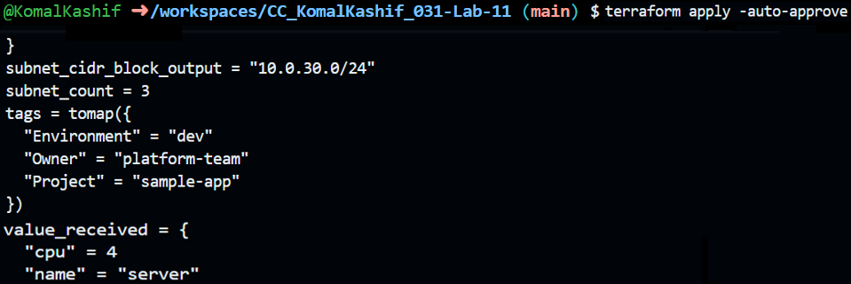
task6_dynamic_value_null.png
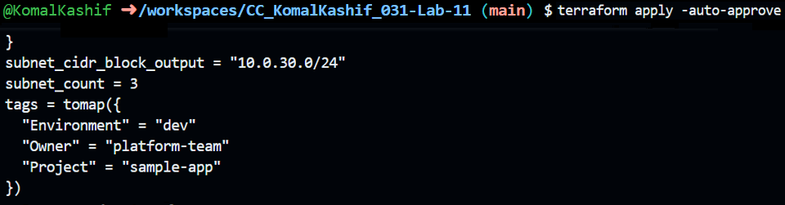
Task 7 — Git ignore
task7_gitignore_created.png
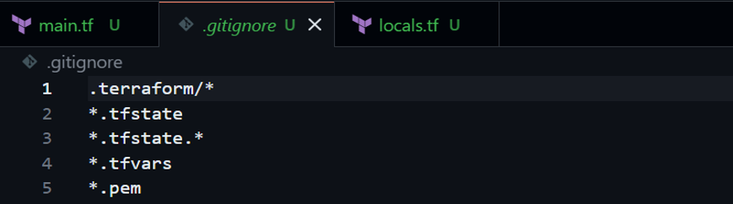

Task 8 — Clean-up then build real infra (VPC, Subnet, IGW, routing, default route table)
task8_clean_files.png
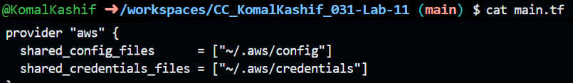
task8_variables_recreated.png
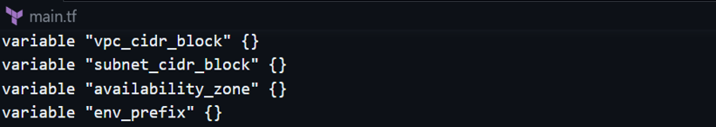
task8_vpc_resources_added.png
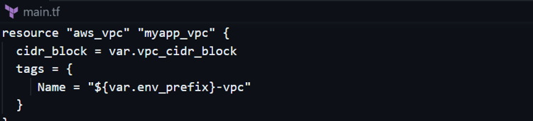
task8_subnet_resources_added.png
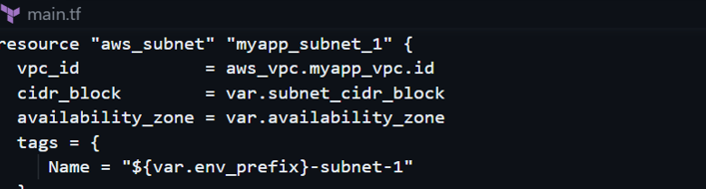
task8_terraform_tfvars_vpc_values.png
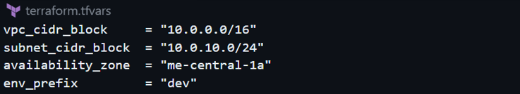

task8_vpc_subnet_apply.png
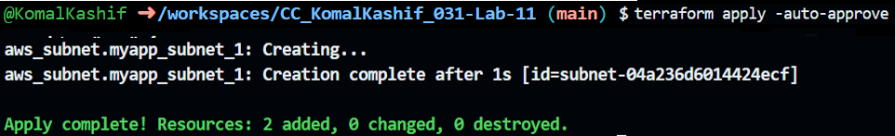

Cleanup:
cleanup_destroy.png
